Metro North Mental Health – Alcohol and Drug Service
Procedure
  - Effective from: August 2020
Review date: August 2021

Shared Care for Medication-Assisted Treatment of Opioid Dependence 005608
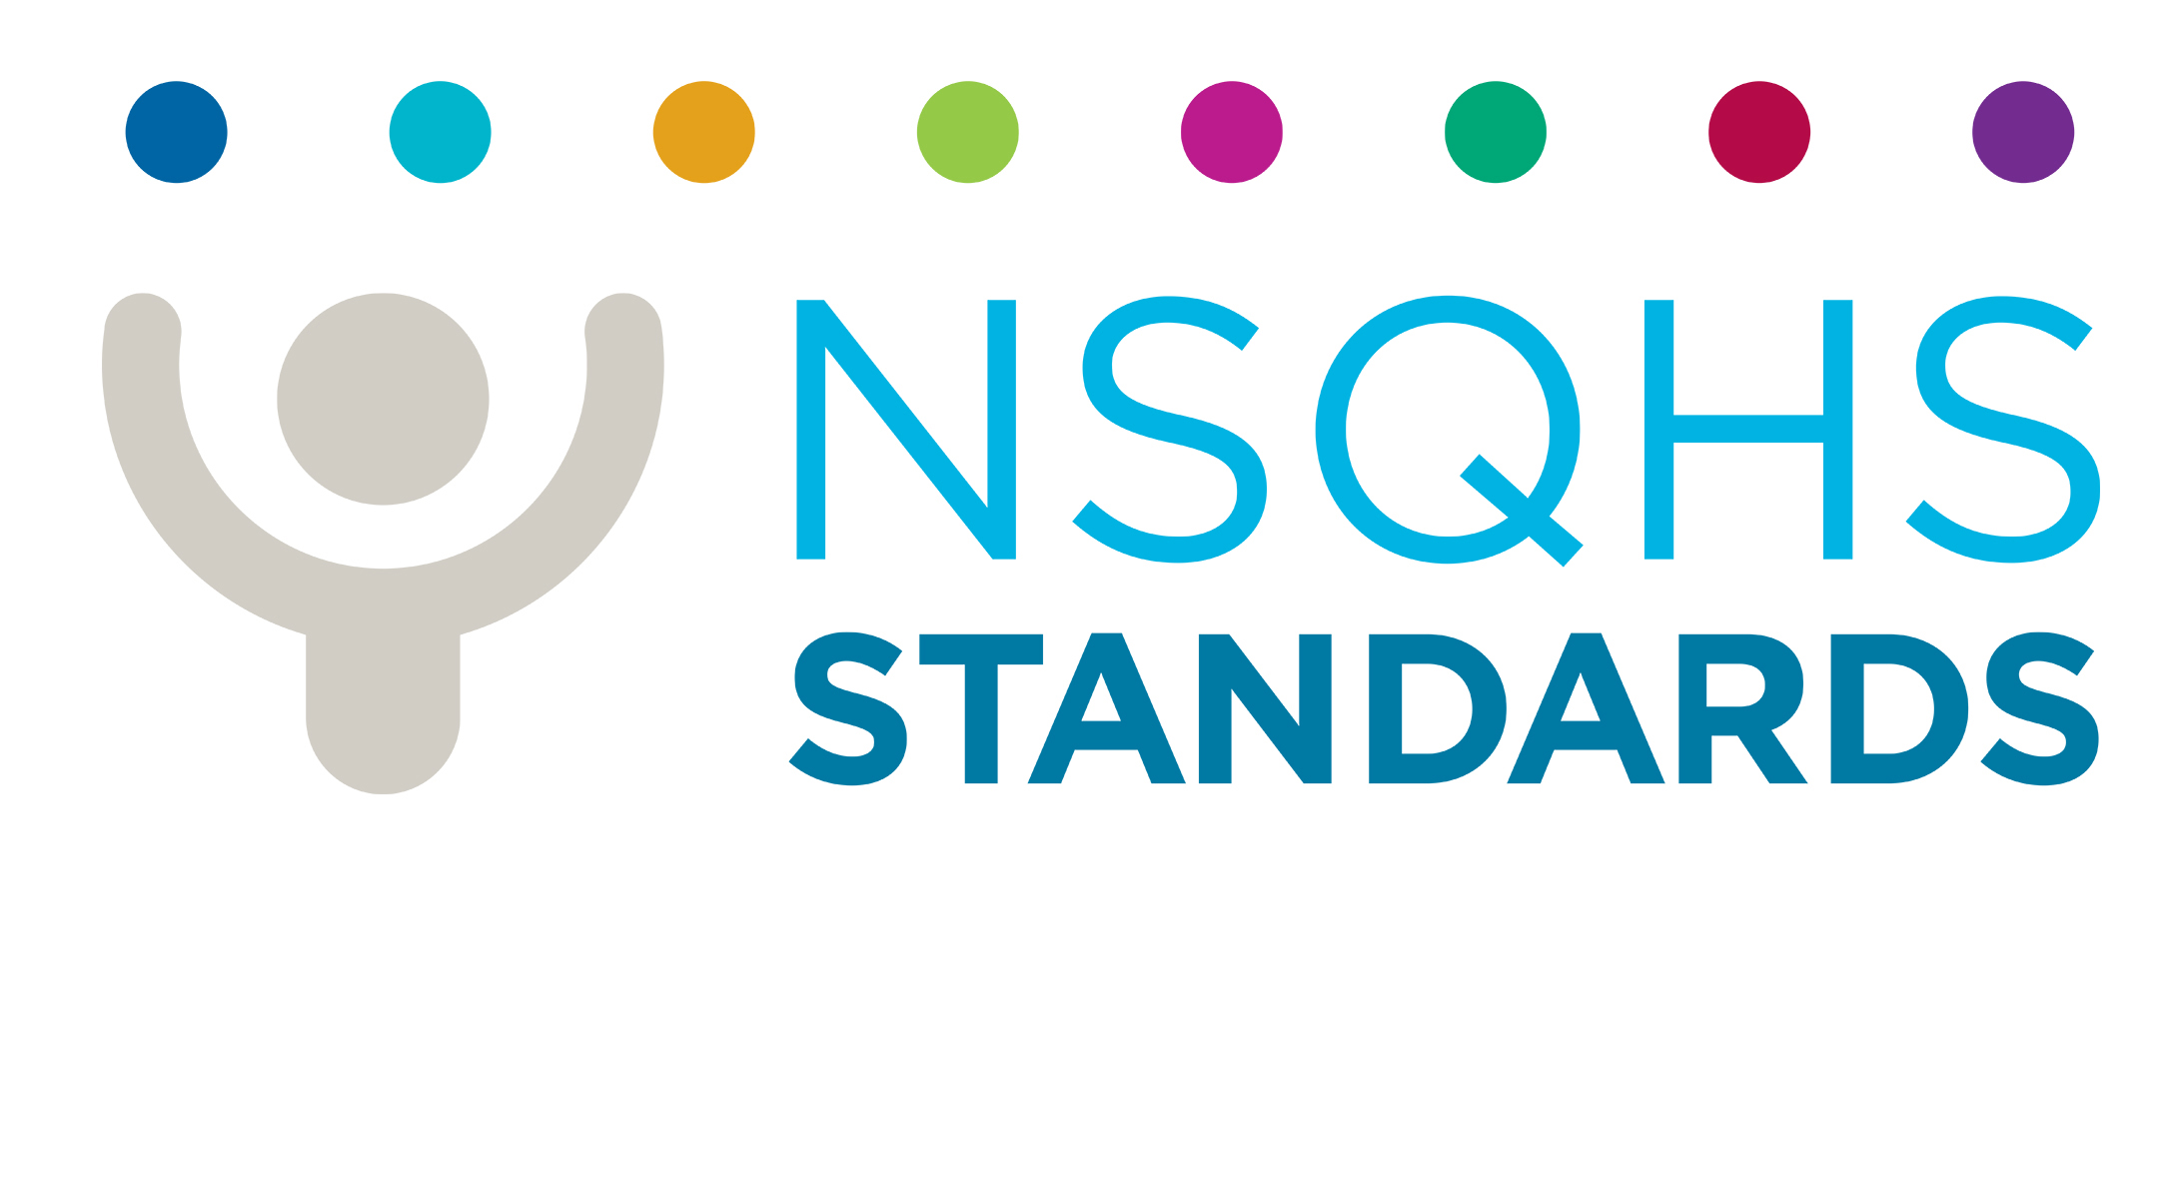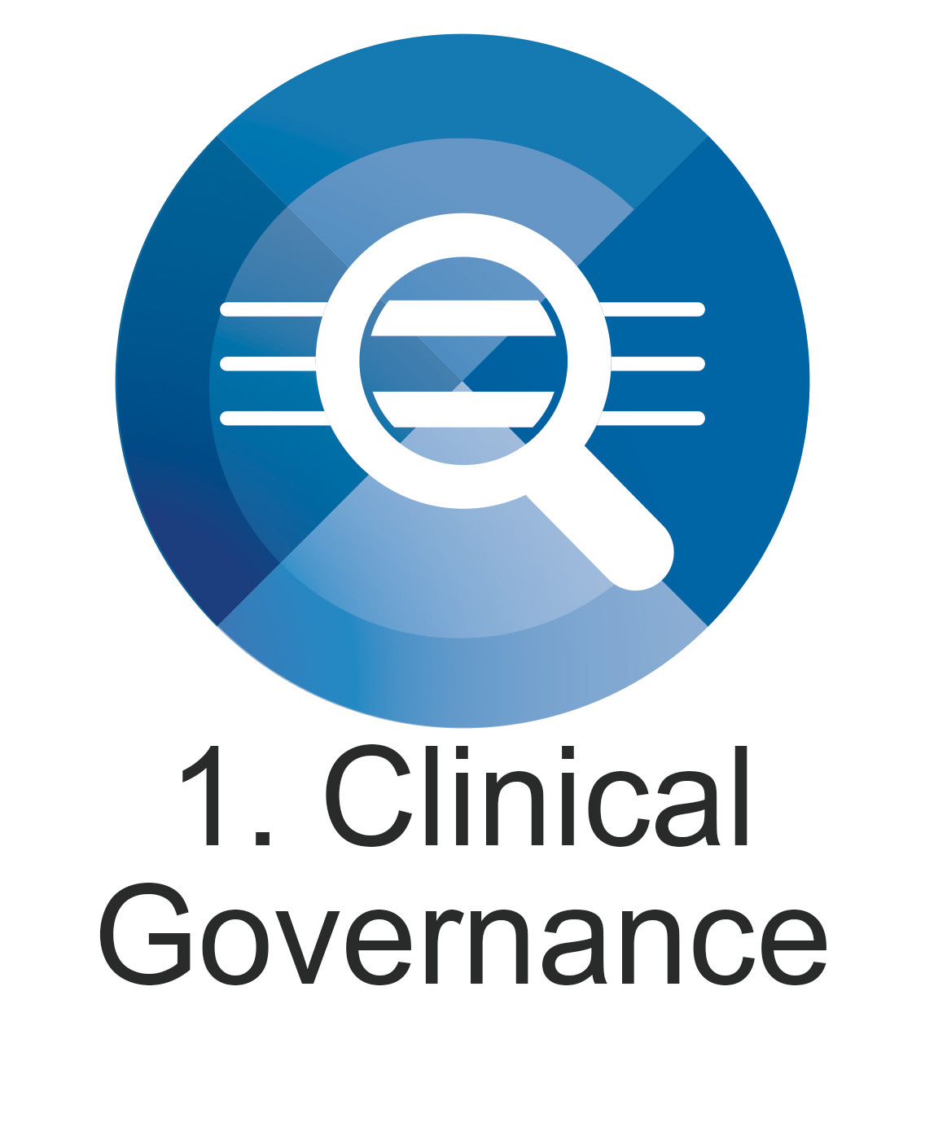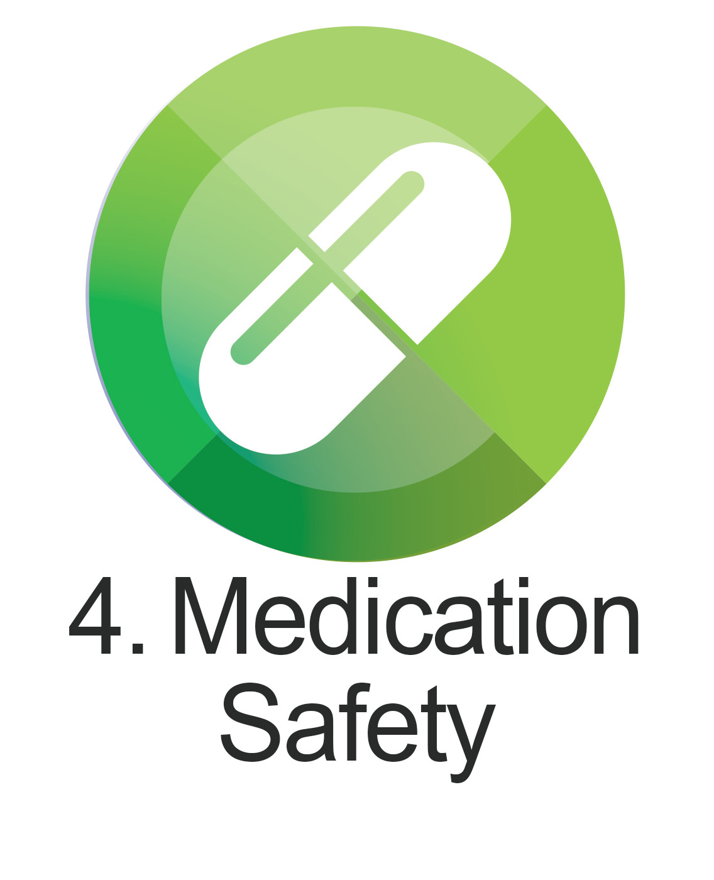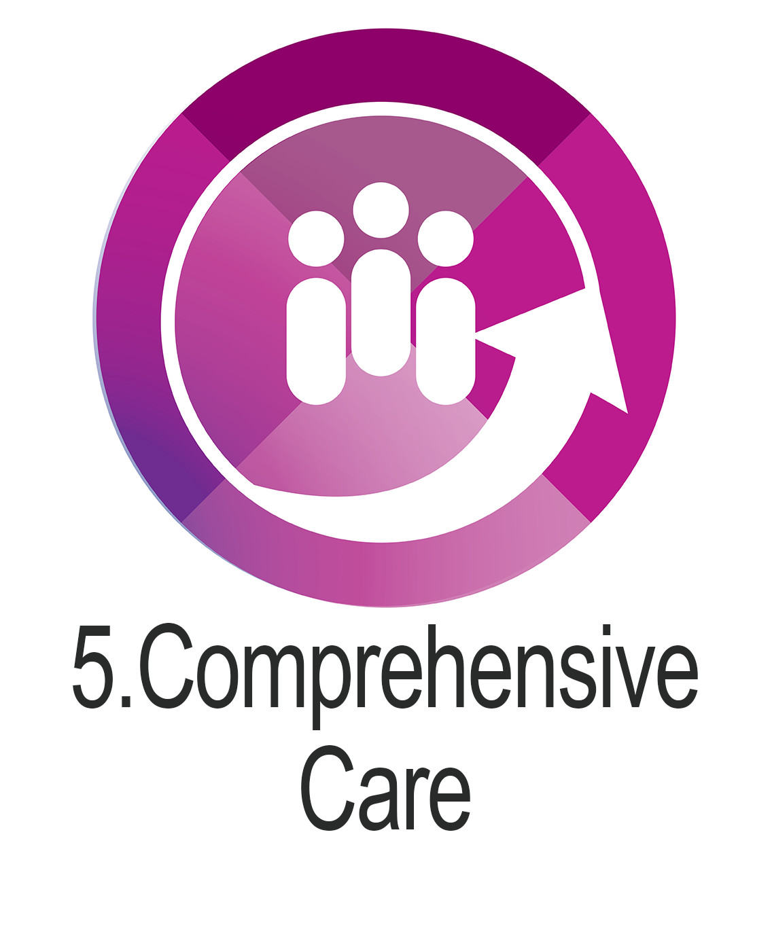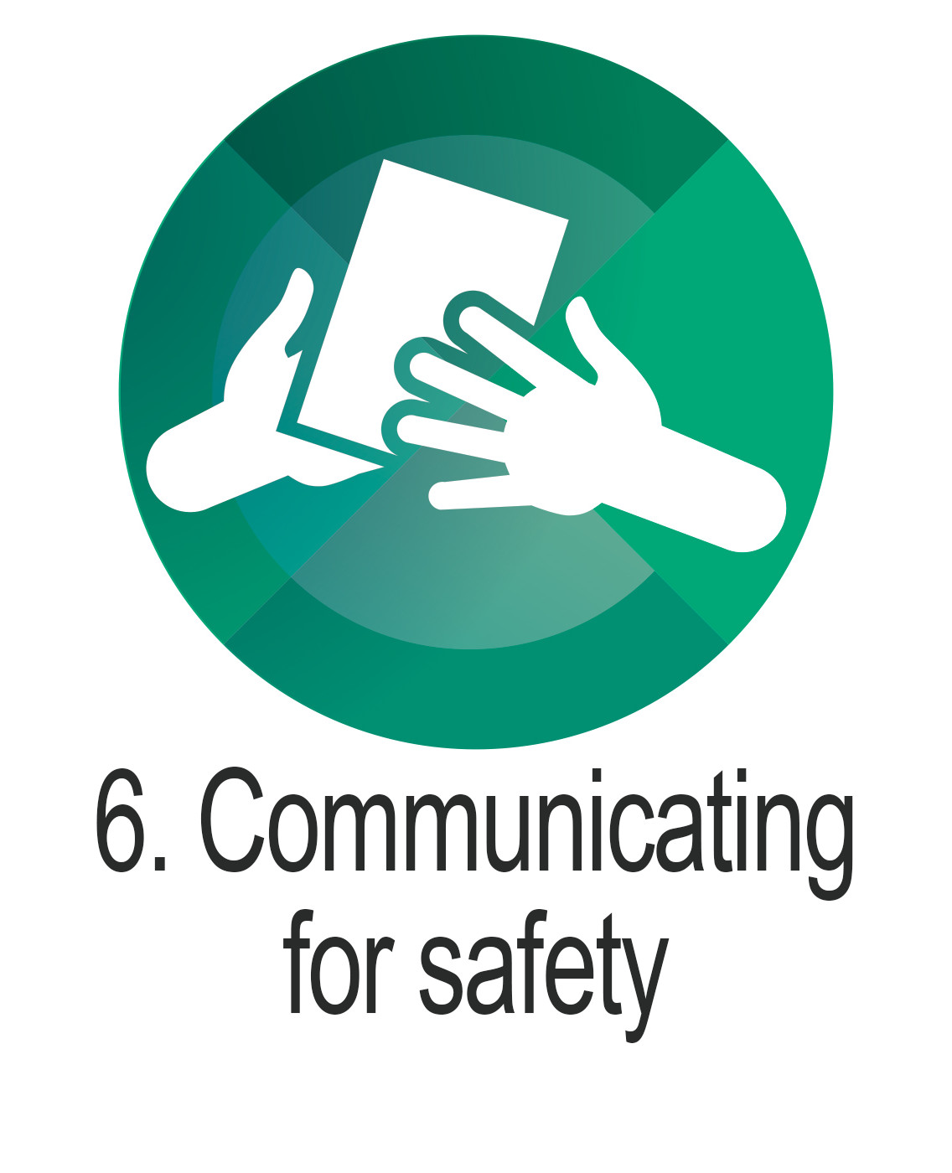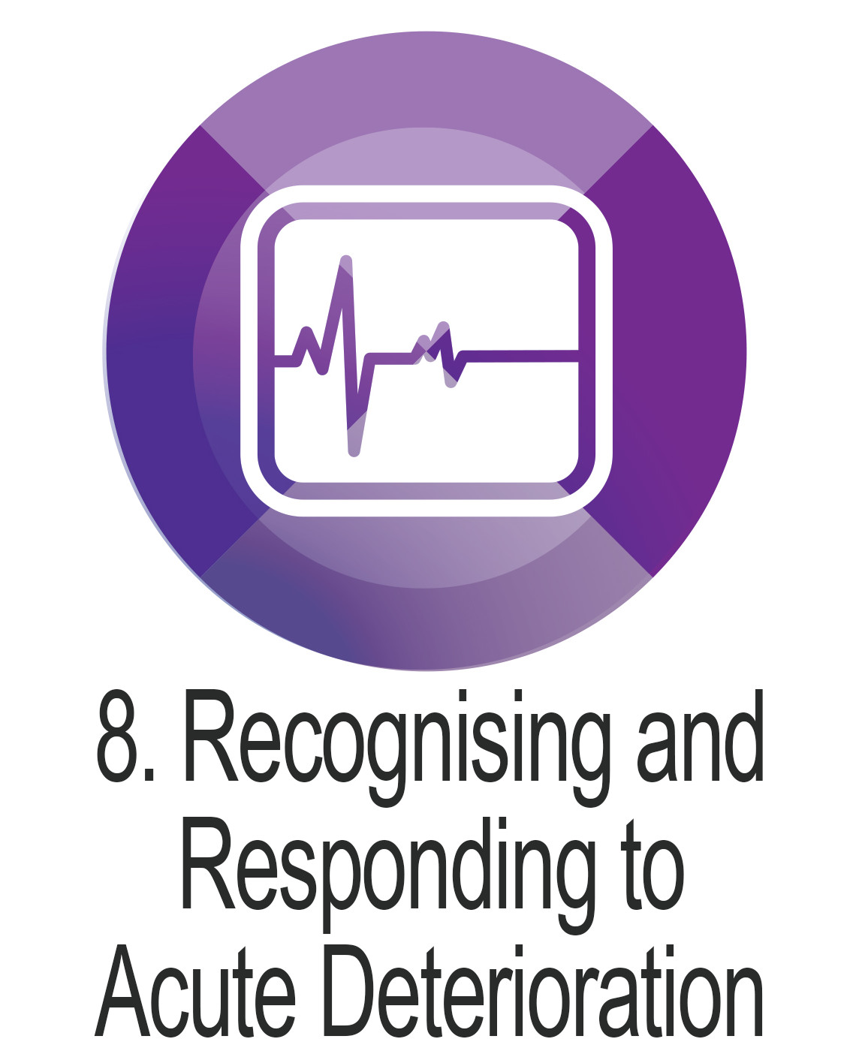

Purpose and intent
This procedure describes the process for the Metro North Mental Health - Alcohol and Drug Service (MNMH-ADS) working with Approved Prescribers, AP (e.g. General Practitioner, Psychiatrist, approved Nurse Practitioner) to provide shared care for patients on Medication-Assisted Treatment of Opioid Dependence (MATOD) as part of the Queensland Opioid Treatment Program (QOTP). While the AP will typically be a General Practitioner, the MNMH-ADS acknowledges that a medical specialist or Nurse Practitioner working in primary health care may fulfil the role.
The purpose of shared care is to promote a model of service delivery where specialist tertiary care services provide access to assessment and treatment planning and the management of complex clients; and stable clients are referred to their AP for ongoing management supported by the MNMH-ADS. Potential benefits include:
- normalisation and recovery orientated approach to ODT
- reduced perceptions of stigma
- improved client autonomy
- the AP (and others working in the same practice) can benefit from having an established link with the MNMH-ADS that will promote referral into ADS and improve referral processes
- clients that are stable will have reduced MNMH-ADS contact allowing timely access to specialist assessment and treatment services for new and/or complex clients
- possible increase in uptake of ODT prescribing by community medical and nurse practitioners (with the relevant completion of training).
The client will remain registered on QOTP with the MNMH-ADS and continue to have a MNMH-ADS prescriber and supported by the clinic Case Manager (CM) and Clinical Nurse Consultant (CNC) Shared Care for Opioid Treatment (SCOT).
The AP will provide regular client reviews and continued prescription of QOTP pharmacotherapy, with support from the MNMH-ADS as required.

Scope and target audience
This procedure applies to:
- all MNMH-ADS ODT clinical and non-clinical staff (permanent, temporary and casual) and all organisations and individuals acting as its agents (including Visiting Medical Officers and other partners, contractors, consultants and volunteers).
This procedure provides guidance to MNMH-ADS staff on the expectations of the AP and pharmacist in providing shared care for ODT in collaboration with the MNMH-ADS.

Principles
- Shared care is a service expectation in line with a recovery approach to care and therefore relevant to all MNMH-ADS QOTP clients, however it is acknowledged that clients require treatment/care plans designed to match their individual needs and case management timelines can differ significantly.
- Effective collaboration between health services and other service providers enables comprehensive care and facilitates continuity and quality service provision for clients.
- The provision of comprehensive care involves a biopsychosocial approach comprising an array of physical, psychological and social service interventions in the provision of care. These interventions are outlined in a comprehensive treatment plan based on, and matched to, the assessment of individual needs and preferences of the client and coordinated within a broad range of provider networks and social services.
- MNMH-ADS recognises the high prevalence of client exposure to traumatic events and is guided by the principles of Trauma Informed Care and Practice (TICP). Education and training in TICP are provided to all staff, and service delivery is adapted to meet the needs of trauma-affected clients and minimise the risk of inadvertent treatment related re-traumatisation.
- Care planning will include input from different healthcare disciplines. Based on the biopsychosocial assessment this care planning may be interdisciplinary or multidisciplinary.
- For a client to provide informed consent for treatment, and to meaningfully engage in the development of their care plan, the client should have a sound understanding of all treatment options relevant to their diagnosis. This ensures that the client is making an informed choice on which treatment type/s they wish to undertake.
- Health literacy plays an important role in providing comprehensive care for clients. For successful collaboration and partnerships with clients, everyone involved must be able to communicate, interpret and act on health information such as diagnosis, treatment options and plans. MNMH-ADS staff are encouraged to work in collaboration with clients and provide health information to them in a way that can be understood.
- The agreed clinical communication tool within Metro North Health (MNH) is Identify, Situation, Background, Assessment, Recommendation (ISBAR). Clinical handover processes and documentation of handover in each setting are to apply the ISBAR framework.
- Sharing client information with other service providers requires the consent of the client. While there are some exceptions to this, it is best practice to obtain client consent to share information. Consent and the sharing of client information should be discussed at initial assessment and be an ongoing subject for discussion throughout treatment. For additional information regarding consent and sharing of a client’s MNMH-ADS treatment/care information, refer to the MNMH-ADS Requests for client information procedure.
- To ensure that MNMH-ADS fosters a culture of person-centred care, MNMH-ADS strives to plan, deliver and evaluate the services provided to ensure that they are founded on mutually beneficial partnerships between clients and MNMH-ADS. Additionally, MNMH-ADS strives to deliver treatment in a manner that gives consideration to human rights including, but not limited to access to health care, respect, privacy, dignity, cultural considerations and humane treatment as per the Human Rights Act 2019.
- The active participation of MNMH-ADS client’s family and/or significant others is encouraged to assist with the delivery of comprehensive care.

Procedure / process
A client may be referred by a medical or nurse practitioner who is concerned by the client’s opioid use, or the client may self-refer to the MNMH-ADS. The referral will be considered applying the MNMH-ADS Triage/Intake Decision Making Framework (refer to Comprehensive Care PROC005343), and where suitable for further assessment, the officers completing the triage/intake will link the client with the most appropriate clinic.
- Client is diagnosed with opioid dependence
The client will attend the nominated MNMH-ADS clinic for assessment, case formulation and treatment planning (refer to Comprehensive Care PROC005343). The diagnosis of an opioid use disorder is based upon a pathological set of behaviours related to the use of opioids as outlined in the 11th revision of International Statistical Classification of Diseases and Related Health Problems (ICD 11).
- Treatment under the Queensland Opioid Treatment Program
The client will be stabilised on the chosen pharmacotherapy (buprenorphine or methadone) in line with the Queensland Medication-Assisted Treatment of Opioid Dependence: Clinical Guidelines 2018 (MATOD Guidelines), and Long-Acting Injection Buprenorphine in the Treatment of Opioid Dependence Queensland Clinical Guidelines: 2019 (LAI-BPN Guidelines).
All clients should be advised of the option and expectation of entering a shared care arrangement once they are stable in their treatment, while acknowledging that individualised client care remains the cornerstone of treatment and timelines can differ significantly. Identification of a suitable shared care prescriber should begin on admission to QOTP for new clients or in routine reviews for existing ODT clients and noted in the client file. Treatment planning and case management should include identification and implementation of necessary supports to assist clients meet shared care stability requirements.
The client will be informed that:
- shared care is the standard model of care for MNMH-ADS, and
- the treatment team will work with the client to progress toward a shared care arrangement.
- Transfer into shared care
The CM will support the client in their recovery process to implement strategies to obtain treatment stabilisation and meet requirements for moving toward a shared care treatment model. With client consent, the MNMH-ADS psychosocial teams can help to improve stability through input into planning support, counselling and skill building. The CM will, in collaboration with the client, consider suitability for shared care at each review. The CM will obtain collateral information from the client’s pharmacist and QScript to support the consideration of client suitability. If the client is considered appropriate for shared care and any barriers have been addressed, the CM will present a case review with the multidisciplinary team (MDT). An MDT review is used to determine suitability of individual clients for shared care and should include consideration of elements identified as indicators of stability (refer to Shared Care Suitability below).
When considered suitable for shared care by the MDT, the CM or CNC will further discuss the model with the client, explain the process and document an outcome in the client file. The CM will obtain client consent to share medical information and file the signed consent form in the client file. The CNC will liaise with the client’s identified prescriber to confirm their agreement to engage in the shared care model.
With agreement of the identified prescriber, the CNC will provide the AP with an information pack on the shared care model of treatment delivery and apply to Healthcare Approvals and Regulation Unit (HARU) for approval for the identified prescriber to provide QOTP prescriptions under a shared care model. Where no issues are identified by HARU, they will provide an approval for one identified prescriber to provide shared care for a specific client using a specified pharmacotherapy. An individual approval is required for each client.
With HARU approval of shared care, the CNC will contact and meet with the AP and practice staff to ensure a shared understanding of the requirements and responsibilities of the shared care model. A date for commencement will be negotiated and a transfer appointment booked for the client. The CNC will provide the AP with a copy of the client’s most recent case review, QOTP prescription and any other relevant information. The CNC will provide the client with a MNMH-ADS 12-month review appointment and inform the AP of the same.
The CNC will contact the client’s dosing pharmacy to advise of the shared care arrangement and provide the AP contact information. The expectations of the pharmacist including reporting responsibilities will be outlined.
The CNC will continue to liaise with the AP and pharmacist to ensure adherence to the treatment model (including attendance for MNMH-ADS review), provide support as required and for early identification of developing issues.
At all times, discussions and decisions made about shared care will be documented in the client file.
The MNMH-ADS is responsible for informing the AP when there is a change of CNC or CM and ensuring the new CNC or CM understands the shared care model and the associated roles and responsibilities of the client and all health service providers. A description of the MNMH-ADS CM, CNC and prescriber responsibilities are provided in Appendix 2.
- Approved Prescriber shared care role
The AP will provide ongoing QOTP scripts, review the client and consult with the MNMH-ADS if issues arise.
The MATOD Guidelines indicate that the AP is to review the client at a minimum of every three months. It is expected that the AP will provide a client report to MNMH-ADS after each client review including information on:
- requested dose adjustments
- other medication
- alcohol and drug use
- mental health concerns or new health conditions, and
- any behavioural or social concerns.
A feature of the shared care model is the safety net provided to the AP by collaborating with the alcohol and drug service. An example of this is the requirement of the AP to consult with the MNMH-ADS when wanting to prescribe medications captured under Queensland’s real-time prescription monitoring system, QScript. In this circumstance the AP does not provide independent management of the client and is required to consult with the MNMH-ADS in the first instance and implement Joint Prescribing Plans as required.
Consultation does not necessarily require a referral to MNMH-ADS and can be initiated by phone/fax/secure file transfer. The CNC or CM will be responsible for determining the need for clinic attendance.
If the AP cannot continue to provide ongoing shared care, MNMH-ADS will resume treatment management for the client. The AP should contact the CNC or CM in the first instance.
The responsibilities of the AP are described in Appendix 2.
- Pharmacist shared care role
The CNC will provide the dosing pharmacist with a handover and AP details. The pharmacist will be expected to provide a report to the AP and MNMH-ADS every three months. The report should include information such as:
- missed doses
- diversion
- client intoxication or drug use issues including doctor shopping
- possible medication interactions
- behavioural issues
- payment issues.
The responsibilities of the pharmacist are described in Appendix 2.
- MNMH-ADS review
The client will be reviewed by their MNMH-ADS prescriber annually developer sooner if required. The CNC or CM will liaise with and review the client as required.
- Fast-track shared care
A ‘fast-track’ option should be available for clients:
- referred from a community medical or nurse practitioner for review and opinion of opioid use
- assessed as appropriate for, and commenced on ODT
- with no history of injecting drug use, and
- with no/minimal history of ‘doctor shopping’ for drugs of dependence.
Treatment planning, commenced when the referral is received, should include discussion with the referrer to determine interest in commencing shared care when the client obtains a stable medication dose. Clinical judgement regarding a stable dose should be used to ensure that no or minimal dose changes will be required after transfer into shared care.

Shared Care Suitability:

The following are general conditions of ODT shared care:
- All clients are eligible for consideration of shared care irrespective of prescribed opioid treatment medication, length of time in treatment with MNMH-ADS or total time in treatment. This includes clients transferred from other Queensland service providers, clients released from Queensland correctional centres and interstate transfers.
- Client suitability for shared care treatment is subject to assessment of treatment stability.
- The identified prescriber agrees, and is able, to provide the client with shared care for their ODT.
Suitability criteria for consideration
The MDT review, used to determine suitability of individual clients for shared care, should include consideration of the following elements which have been identified as indicators of QOTP client stability.

Stable dose – there should be no or minimal (such as a dose a reduction plan) expected dose adjustments required.

Buprenorphine - there is no dose limit for buprenorphine medications.

Methadone - there is no dose limit for methadone, however higher doses require greater consideration. Where the dose is 120mg/24mL or greater, the AP must agree to undertake the extra monitoring required such as performing regular ECGs in determining the length of the corrected QT interval (QTc).

Treatment compliance – the client is compliant with meeting treatment requirements, review requirements/appointments.

If clinic attendance is irregular an assessment should be made to determine causal factors and consideration should include if a move to shared care would address issues effecting attendance record.

Alcohol use - is within safe limits according to Australian Guidelines (Australian guidelines to reduce health risks from drinking alcohol 2009).

Illicit substance use – where the client has ongoing illicit drug use, it does not significantly impact mental health, personal or social functioning and does not pose a significant medical risk to the client.

Mental health - clients with a current mental illness diagnosis must have a management plan in place and be supported by relevant services where required.
- Psychosocial support - a medically stable client who requires ongoing psychosocial support should be considered for shared care if the treatment plan outlines management of these needs. Psychosocial support can be provided through the MNMH-ADS, NGO or private services as appropriate and agreed to by the client.

Legal - where the client has ongoing legal issues, the AP should be advised if there is a possibility of interruption or impact to treatment (with client consent).
- Child safety – where child safety issues are present, implemented strategies and support details should be provided to the AP.

Personal functioning – the client demonstrates stable personal functioning with consideration to matters such as:
  - attends to activities of daily living
  - manages financial responsibilities (particularly in relation to treatment requirements)
  - maintains family role / relationships
  - manages risk to self and others
  - manages health
  - stable accommodation (relevant to client’s needs)
  - if disability is present, a carer is available to support the client with above.

Pharmacy - input should be obtained from the dosing pharmacist.

The client should be compliant with dosing as per the prescribed regimen and the financial obligation to the pharmacy is managed to an acceptable level (e.g. regular payments made/debt management plan in place).
While the elements of stability identified above should be considered, it is acknowledged that at times, clients may have difficulties with some elements (e.g. accommodation). This should not preclude a client from participation in shared care but prompt the implementation of (agreed upon) support measures to address the issues identified.

Partnering with clients
The MNMH-ADS aims to provide trauma-informed, person-centred care that facilitates a recovery-oriented approach to treating people with opioid dependence. Providing person-centred care; treating each client respectfully as an individual with consideration of client comfort and surroundings, beliefs and values, will deliver personal, clinical and organisational benefits¹. MNMH-ADS will involve clients in their own care (with consideration of their health literacy), supporting them to make informed decisions about their ODT and providing treatment options suited to their individual circumstances.

Aboriginal and Torres Strait Islander considerations
The Institute for Urban Indigenous Health were consulted with recognition of their provision of health services to Aboriginal and Torres Strait Islander individuals and communities. IUIH and their member organisations Moreton Aboriginal and Torres Strait Islander Community Health Service (ATSICHS) and ATSICHS Brisbane provide six primary health care clinics across Brisbane North.

Legislation and other authority
The shared care model, ensuring the level of care required is delivered in the most appropriate setting, aligns treatment with:
- Department of Health Strategic Plan 2019-2023
- Connecting Care to Recovery 2016-2021
- Queensland Medication-Assisted Treatment of Opioid Dependence: Clinical Guidelines 2018
- Metro North HHS Strategic Plan 2016-2020 (revised 2019)
- Metro North Mental Health Clinical Services Plan 2018 - 2023
- Shifting Minds: Queensland Mental Health, Alcohol and Other Drugs Strategic Plan 2018-23.
The Health (Drugs and Poisons) Regulation 1996 underpins medication-assisted treatment of opioid dependence in Queensland.

References
- Australian Commission on Safety and Quality in Health Care. Patient-centred care: improving quality and safety through partnerships with patients and consumers. Sydney: ACSQHC, 2011.

Related documents
Queensland Medication-Assisted Treatment of Opioid Dependence: Clinical Guidelines 2018
Long-Acting Injection Buprenorphine in the Treatment of Opioid Dependence Queensland Clinical Guidelines: 2019
Metro North Mental Health – Alcohol and Drug Service Procedure PROC005343 - Comprehensive Care
Metro North Mental Health – Alcohol and Drug Service Procedure 004264 – Client Participation and Engagement
Metro North Mental Health Guideline 003633 – Consumer and Carer Participation and Engagement within Metro North Mental Health

Appendix 1- Definition of terms
Term | Definition
Approved Prescriber (AP) | General practitioner, specialist or nurse practitioner approved by the Healthcare Approvals and Regulation Unit to prescribe opioid treatment medications for clients in a shared care arrangement with Metro North Mental Health – Alcohol and Drug Service under the Queensland Opioid Treatment Program.
Case Manager (CM) | Metro North Mental Health – Alcohol and Drug Service health clinician responsible for the client’s treatment under the Queensland Opioid Treatment Program.
Clinical Nurse Consultant (CNC) | Dedicated Metro North Mental Health – Alcohol and Drug Service registered nurse dedicated to coordination and support of shared care.
MNMH-ADS Prescriber | Medical officer  - Addiction Medicine Specialist  - Psychiatric Addiction Specialist  - Senior Medical Officer  - Psychiatric Registrar  - Nurse practitioner
Queensland Opioid Treatment Program (QOTP) | Regulatory framework for the provision of opioid dependence treatment prescriber and dispensary services, and treatment admission and discharge requirements.
Client | People seeking assistance with opioid dependence issues and engaged with opioid dependence treatment service providers. The terms patient, service user, consumer, person who uses drugs are used in various other settings.
Opioid Dependence Treatment (ODT) | Treatment approach for people who are opioid dependent using a combination of medication and psychosocial support. Other terms used to describe treatment for opioid dependence with medication include opioid treatment program, opioid substitution treatment/therapy, opioid replacement treatment/therapy.
Healthcare Approvals and Regulation Unit (HARU) | Queensland Government unit with administrative oversight of the QOTP.
Multidisciplinary team (MDT) | Clinics providing medication-assisted treatment of opioid dependence use a multidisciplinary approach using combinations of specialist medical, nursing and allied health professionals. A MDT review will consist of at least two different health professional disciplines.
Metro North Mental Health – Alcohol and Drug Service (MNMH-ADS) | All alcohol and drug services provided by Metro North Health.

Appendix 2 – Roles and responsibilities

Role | Responsibilities
Client | - Comply with shared care arrangement conditions.  - Attend all appointments scheduled with AP and MNMH-ADS.  - Contact the AP if there are any requests or changes required to their QOTP script (including dose and take away doses, TADs).
Case Manager (CM) | - Assess clients for shared care suitability through clinical reviews.  - Discuss shared care with clients, identifying barriers to engaging in shared care and supporting the client in implementing strategies to manage those barriers.  - Obtain collateral information from pharmacist and QScript to support consideration of suitability.  - Assist the client to identify a shared care provider.  - Present a case review of clients to the MDT for consideration of shared care suitability.  - Inform CNC of client suitability for shared care.
Clinical Nurse Consultant (CNC) | - Contact the client’s identified AP to confirm agreement to provide shared care treatment.  - Coordinate application for approval from the HARU for the AP to prescribe pharmacotherapy for the client.  - Attend the offices of the AP for the purpose of providing training and support (for AP and support staff) in:  - the responsibilities of ongoing treatment  - reporting requirements  - completing QOTP prescription and other necessary documents.  - First point of contact within MNMH-ADS for AP.  - Link to specialist prescribers.  - Provide advice/assistance and guidance on any issue or concern regarding the client’s treatment under the QOTP.  - Provide client review as required.  - Assist the AP in coordinating intra/interstate dosing for the patient as required.  - Advise AP on dosing during public holidays as required.  - Recommend a client review schedule to the AP in line with the ODT Guidelines. The maximum period between reviews is 3 months.  - Coordinate QOTP scripts, on behalf of the AP, from MNMH-ADS in unexpected or urgent circumstances.  - Coordinate annual reviews at MNMH-ADS with notification to the client and AP.  - Support the AP to access QOTP prescriber training through Insight.  - Inform the AP about non-business hours support via the Alcohol and Drug Clinical Advisory Service (ADCAS), 7 days per week (8am- 11pm).  - Inform the AP about specialist education opportunities through Insight webinars, workshops and online packages.  - Inform the client and AP about client telephone support (additional to CNC or CM) via adis 24/7 alcohol and drug support on 1800 177 833.
Approved Prescriber (AP) | - Conduct QOTP reviews in accordance with the ODT Guidelines. The maximum period between review is 3 months.  - Provide ongoing QOTP scripts to the nominated dosing pharmacy.  - At the initial shared care appointment, complete the initial QOTP script and send to the nominated pharmacy (a signed copy should be kept on the client’s file).  - The QOTP script must be provided directly (e.g. mailed) to the pharmacy. Do not provide to the patient.  - A faxed copy of the QOTP script can be provided to the pharmacy if required urgently.  - QOTP scripts can be provided for a maximum of 3 months.  - When planning leave, provide the nominated pharmacy with QOTP scripts for the period of leave.  - Ensure practice staff provide relevant information to MNMH-ADS in a timely manner. [If unexpected and urgent circumstances result in the AP being unavailable, MNMH-ADS will provide interim QOTP scripts.]  - Consult with the CNC (in the first instance) if dose adjustments are required. [The AP is not approved to change the client’s dose without consultation with MNMH-ADS]  - Change TAD arrangements (TAD days, number of TADs) in line with ODT Guidelines.  - Alter the dosing regimen for Suboxone®, from single (daily) dosing to double or triple (every 2nd or 3rd day respectively) dosing, providing the daily dose does not exceed 32mg.  - Change the nominated dispensing pharmacy in consultation with the client and pharmacies.  - Contact MNMH-ADS prior to prescribing any new medications captured under QScript (all S8s, all benzodiazepines, codeine, gabapentinoids, quetiapine, tramadol, zolpidem and zopiclone). Implement a Joint Prescribing Plan as appropriate.  - Contact MNMH-ADS prior to prescribing fluvoxamine for clients on methadone.  - Refer to NGO support agencies where psychosocial support is required and with client consent. Please contact the CNC or CM for review/guidance.  - The AP will ensure the client attends MNMH-ADS annual reviews.  - The AP will contact MNMH-ADS for advice if there are any concerns about client stability.
MNMH-ADS Prescriber | - Participation in MDT review for client suitability.  - Conduct annual clinical review of client.  - Clinical support to AP as required, for instance when the AP is considering treatment of the client with medications captured under QScript.  - Provide interim QOTP scripts on behalf of the AP in unexpected/urgent circumstances where AP is unavailable.
Healthcare Approvals and Regulation Unit (HARU) | - Provision of approval to AP as a shared care provider.  - Regulatory advice and support.
Pharmacist | - Contact the AP with any concerns regarding QOTP scripts.  - Advise the AP of any client dosing concerns.  - Provide a 3-monthly pharmacy report to the AP and MNMH-ADS (more frequently if required).

Appendix 3 – Shared care process flowchart

Document history
Author | Clinical Nurse Consultants, Shared Care for Opioid Treatment Project  Metro North Mental health – Alcohol and Drug Service.
Custodian | Operations Director, MNMH-ADS.
Compliance  evaluation  and audit | Clinical incidents.  Client, staff, Approved Prescriber, Pharmacist and service feedback.
Replaces Document/s | Not applicable.
Consultation | Key Stakeholders  All MNMH-ADS, Brisbane North Primary Health Network (PHN), Healthcare Approvals and Regulation Unit (HARU) and MNMH-ADS Safety and Quality Committee.  Broad Consultation  Sunshine Coast ADS, Central Queensland ADS, Metro South ADS, Individual GP, Pharmacists, Brisbane North AOD Partnership Group, General Practice staff, Institute for Urban Indigenous Health (IUIH) and Non-Government Organisations
Marketing Strategy | This document will be available for review by staff working across MNMH-ADS.
Key words | Shared care  Opioid dependence  Queensland Medication-Assisted Treatment of Opioid Dependence: Clinical Guidelines 2018
Custodian Signature | Date
Mark Fairbairn
Operations Director, Metro North Mental Health – Alcohol and Drug Service
Metro North Health

AUTHORISATION
Authorising Officer Signature | Date
Mark Fairbairn
Operations Director, Metro North Mental Health – Alcohol and Drug Service
Metro North Health

The original signed version is kept in file at the Business Support Unit, Metro North Mental Health – Alcohol and Drug Service, Metro North.

