Brief Education Tool
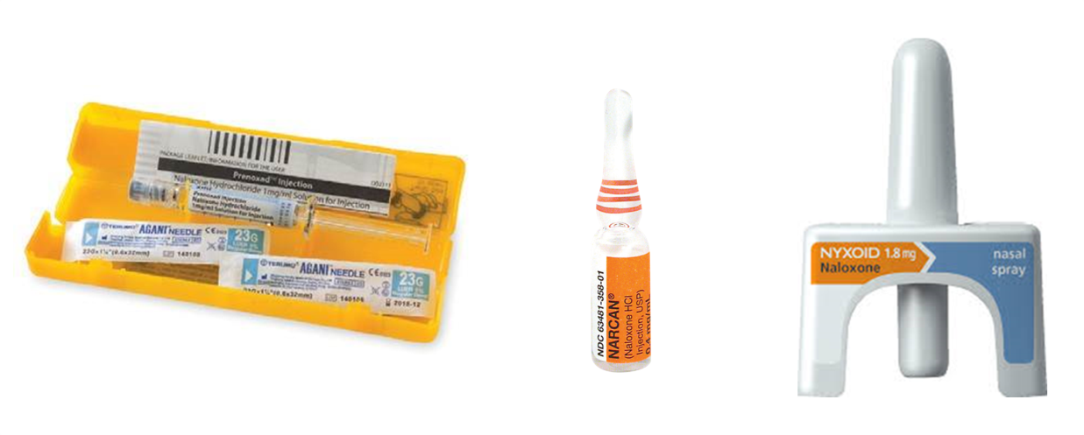

Recognising & responding
to opioid overdose

Introduction
This brief education tool has been developed to support wider access to naloxone for people who may experience, witness and/or respond to overdose.
This tool will assist frontline workers who have direct contact with people who use opioids or who a likely to witness opioid overdose. Frontline workers will be able to deliver a brief education session and deliver key harm reduction messages, before supplying naloxone or linking to naloxone access.
In order to use this brief education tool, the worker should:
- be confident in the use of the Recognise and Respond audio-visual resource
- have the ability to discuss and explore in depth, the signs and symptoms of opioid overdose,
- be able to provide education on how to effectively respond to overdose and administer naloxone
- have attended face-to-face WA Naloxone Project training
- hold a First Aid, Basic Life Support or Provide CPR certificate
- be familiar with the use of naloxone formulations such as; Prenoxad™, Narcan™, and Nyxoid®
Target audience: who should use this brief education tool?
- Naloxone project workers
- Alcohol and other drug workers (AOD)
- Needle Syringe Program workers (NSP)
- Frontline workers who have contact with people who use opioids or who are likely to witness overdose
Target audience: who should receive the brief education session?
- People who use opioids
- People at risk of opioid overdose
- People who may be likely to witness opioid overdose
- Family, friends, significant others of those who use opioids
Upon completion of the brief education session a person should be able to:
- Recognise the signs and symptoms of opioid overdose
- Respond to opioid overdose
- Administer naloxone
- Understand post-naloxone management and care
- Supply naloxone or link people to naloxone access

Background
In 2012 the World Health Organization (WHO) established a process to consider the use of naloxone and the resuscitation of people experiencing opioid overdose. As a result, in 2014 the WHO released guidelines entitled Community Management of Opioid Overdose. In order to reduce the number of fatal overdoses and the harms and effects of non-fatal overdoses, the WHO guidelines recommend that those who are likely to witness an opioid overdose; have access to naloxone and be given instruction in its administration, for the purpose of using naloxone for the emergency management of suspected overdose.
Take home naloxone projects have been operating in Australia since 2011. As part of ongoing intervention to reduce the rate of opioid overdose, naloxone supply should be supported with appropriate brief intervention.
Key points on opioid overdose and naloxone:
- When a person has an opioid overdose, they lose consciousness and their breathing can slow and eventually stop. This results in damage to the brain and other organs and, finally, death.
- Most overdose deaths occur more than an hour after last injection and other people, such as friends or family, are usually nearby. Naloxone is a medicine that temporarily reverses the effects of heroin and other opioid drugs. It does not produce any intoxication itself and has no effect on people who do not have opioids in their system.
- For over 40 years naloxone has been used in medicine to reverse the effects of opioid overdose. In this capacity it has been shown to be safe, reliable and effective. In Australia, as elsewhere, naloxone is widely used in hospital emergency departments and most ambulance services as a key response to opioid overdose.
- Opioid overdose can be managed by monitoring the person, maintaining their airway, providing ventilation (with rescue breathing), basic life support and calling an ambulance.
- Naloxone administration can greatly assist in reversing overdose by helping to quickly restart normal breathing.
- There is no evidence that wider availability of naloxone leads to riskier or more widespread drug use.
*Naloxone is sometimes confused with naltrexone. Naltrexone is used to treat dependence on alcohol, heroin and other drugs, not overdose.
Offering a brief education session on recognising and responding to opioid overdose including the use of naloxone
Use the following 10 step process:
- Explain the process will take approximately 20-25 minutes (if using the audio-visual resource)
- If using the audio-visual scenario, discuss that it contains images of injecting, drugs, drug paraphernalia, overdose and fatal overdose; which may be a trigger for use, relapse, grief and loss.
- Discuss the quiz component with the person and why this tool is used i.e. ‘to assess knowledge, it is not a test’. Give the person choices in how they would like to work through the quiz; (taking into consideration literacy levels) i.e. self-completed, side by side, Q&A.
- Discuss the person’s responses; acknowledge the person’s current awareness, clarify areas that require additional education.
- Watch the audio-visual resource (if possible/practicable), discuss and reinforce key messages.
- Reinforce the following key messages:
- Symptoms of overdose include: blue lips; pale, clammy skin; shallow breathing; non-responsive; not breathing; snoring, gurgling sounds; ‘on the nod’, slumped posture
- Reduced tolerance: leaving prison, detox, or have not used in a while, can increase overdose risk
- Purity: fluctuations, poly-drug, potentiation can increase overdose risk
- Using alone can increase the risk of overdose
- Never leave someone to ‘sleep-off’ an overdose
- Call an ambulance immediately on (Triple Zero) 000
- Other health considerations: hepatitis c, ageing can increase overdose risk
- Using in a different environment: using with different people in different places, i.e. ‘using in a parked car with peers, when usually use is at home with friends’
- Administer naloxone - intramuscular or intranasal according to the device
- Stay with the person until medical help arrives
- Naloxone wears off in around 60 minutes, the person could drop again
- It is safe to administer more naloxone at any time
- Supply naloxone or link the person to naloxone access.
- Check in with the person. Remind them of self-care, as the images and discussion may raise some issues for them at a later time. Where possible provide links to support, debrief and/or counselling opportunities/services.
- Give the person a Recognise and Respond (opioid/blue) fold-out resource. Remind the person if they cannot remember the steps in the event of an overdose to use the Recognise and Respond card flow chart.
See flow chart from the fold out resource on the following page

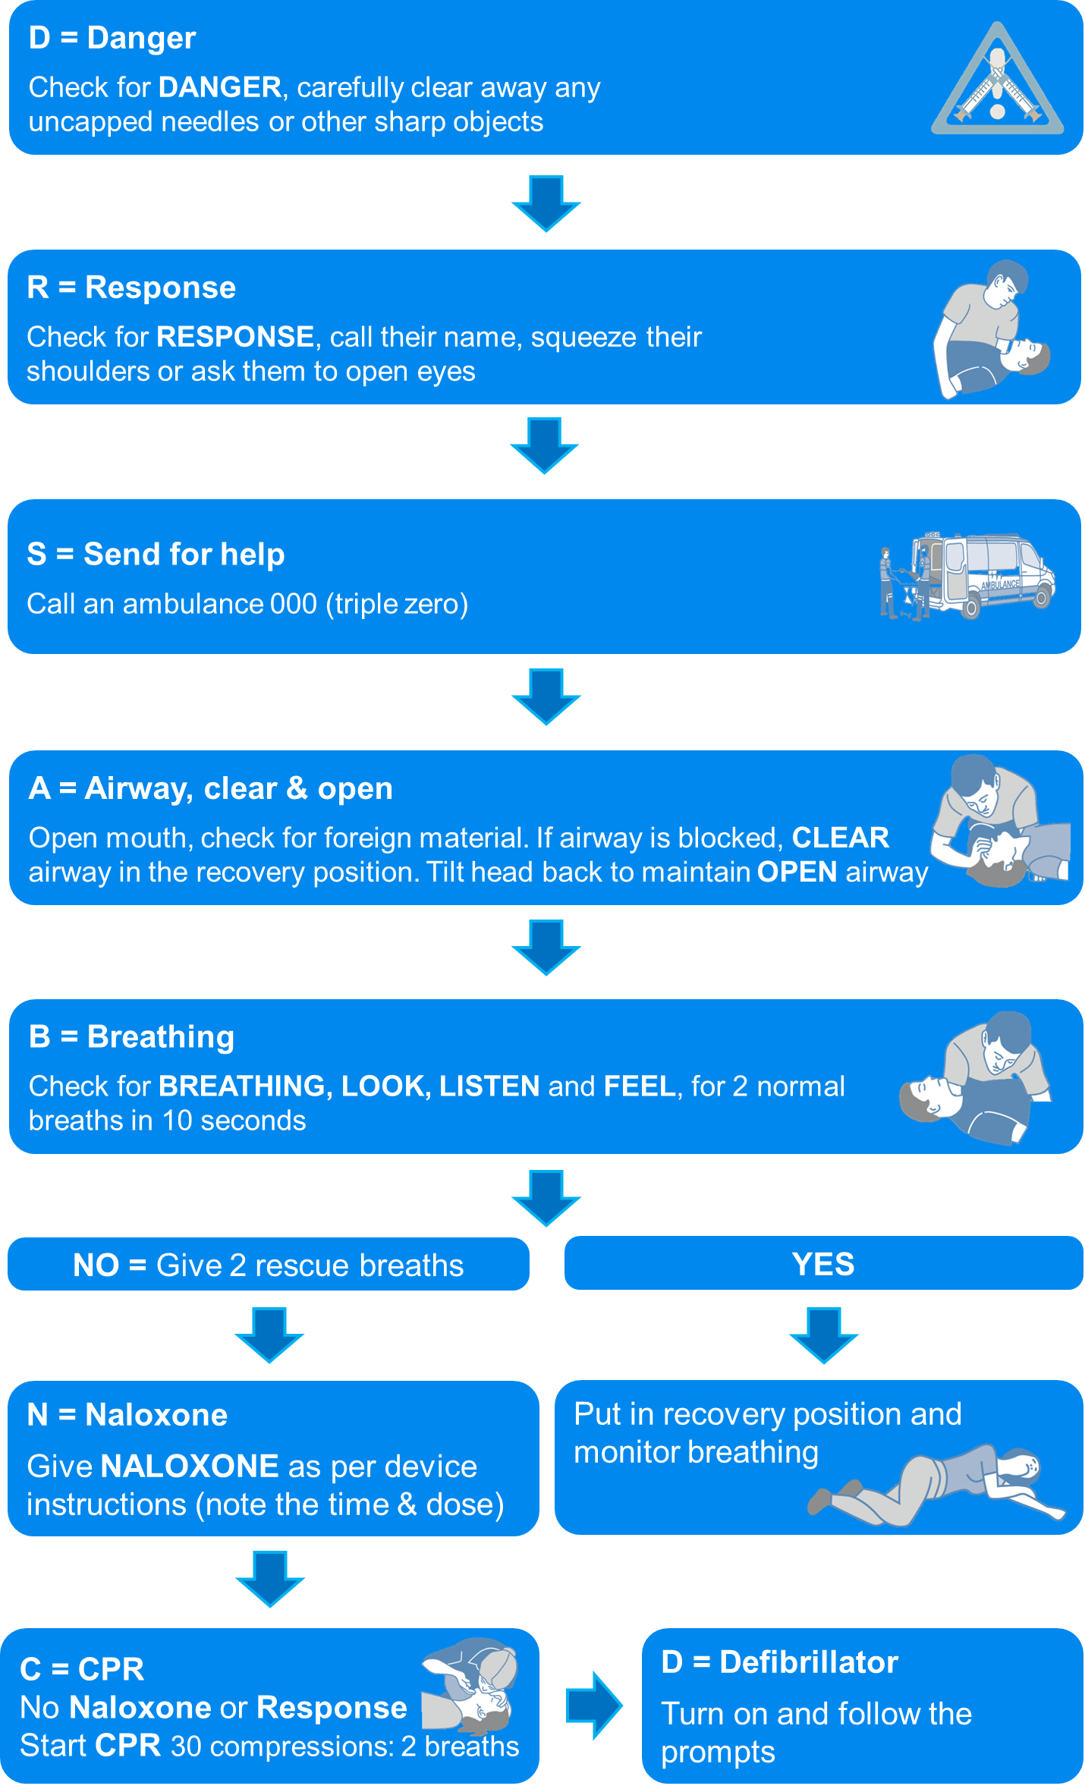

Printable quiz: Recognising and responding to opioid overdose and naloxone administration
(tick all that apply)
1. Which of the following can increase the risk of an opioid overdose?
- using too much heroin/opioids
- change in purity
- using heroin/opioids with other drugs (e.g. alcohol, benzos)
- using heroin/opioids alone
- change in tolerance (e.g. haven’t used in a while, after detox, prison)
- using in unfamiliar places, with unfamiliar people
2. Which of the following may be signs of an opioid overdose?
- slow, shallow breathing
- blue lips
- loss of consciousness, won’t wake up
- snoring, gurgling sounds
- slumped posture
- clammy skin
- ‘On the nod’ - in and out of conversation and sleep
3. What would you do in the event of an overdose?
- call an ambulance, Triple Zero, 000
- stay with the person until they come around
- walk the person around the room
- inject saline, salt water
- give stimulants (e.g. amphetamines, coffee)
- shake the person
- splash the person with cold water
- place the person in a bath or running shower
- perform mouth to mouth resuscitation
- place the person in the recovery position
- give naloxone (Prenoxad™, Narcan™ or Nyxoid®)
- stay with the person until the ambulance arrives
- give naltrexone
4. What is naloxone used for?
- to reverse opioid overdose (e.g. heroin, methadone)
- to reverse amphetamine overdose
- to reverse alcohol overdose
- to reverse any drug overdose
- to reverse benzodiazepines ‘benzos’ overdose
- not sure
5. In an overdose situation, what is the recommended way to administer take-home naloxone?
(tick all that apply)
- intramuscular injection (inject into the muscle)
- intravenous (inject into the vein)
- oral consumption, swallow (tablet or liquid)
- nasal spray (spray into the nose)
- subcutaneous injection (inject under the skin)
6. What is the preferred location for injection?
- upper outer thigh
- upper outer buttock
- upper outer arm
- vein
- subcutaneous tissue
7. How long does naloxone take to start working?
- 2 - 5 minutes
- 5 -10 minutes
- 10 - 20 minutes
- other________
8. How long does naloxone last?
- less than 20 minutes
- 1 – 6 hours
- 60 – 90 minutes
9. How long before another dose of naloxone can be given?
- 3 minutes
- 10-20 minutes
- 1 hour
- anytime is ok
10. What are the steps when giving intranasal naloxone?
- place the person on their back
- squirt the naloxone into the persons mouth
- spray all of the intra-naloxone Nyxoid® into one nostril
- test pump the nasal spray
Note: this quiz was adapted from the OOKS Scale

Printable answer sheet: Recognising and Responding to Opioid Overdose
1. Which of the following can increase the risk of an opioid overdose?
- using too much heroin/opioids
- change in purity
- using heroin/opioids with other drugs (e.g. alcohol, benzodiazepines)
- using heroin/opioids alone
- change in tolerance (e.g. haven’t used in a while, after detox, prison)
- using in unfamiliar places, with unfamiliar people
2. Which of the following may be signs of an opioid overdose?
- slow shallow breathing
- blue lips
- loss of consciousness, won’t wake up
- snoring, gurgling sounds
- slumped posture
- clammy skin
- ‘on the nod’ in and out of conversation and sleep
3. What would you do in the event of an overdose?
- call an ambulance, Triple Zero, 000
- stay with the person until they come round
- walk the person around the room
- inject saline, salt water (has no overdose reversal effect)
- give stimulants (e.g. amphetamines, coffee) (giving stimulants may increase health complications and does not reverse the effects of overdose)
- shake the person
- splash the person with cold water
- place the person in a bath or running shower (may create drowning risk, makes the person difficult to handle if wet and in an area of danger, i.e. hard, sharp surfaces)
- perform mouth to mouth resuscitation
- place the person in the recovery position
- give naloxone (Prenoxad™, Narcan™ or Nyxoid®)
- stay with the person until the ambulance arrives
- give naltrexone
4. What is naloxone used for?
- to reverse any drug overdose
- to reverse opioid overdose (e.g. heroin, methadone) (naloxone only reverses the effects of opioid overdose)
- to reverse amphetamine overdose
- to reverse alcohol overdose
- to reverse benzodiazepines ‘benzos’ overdose
- not sure
5. In an overdose situation, what is the recommended way to administer take home naloxone?
(tick all that apply)
- intramuscular injection (inject into the muscle)
- intravenous (inject into the vein)
- oral consumption, swallow (tablet or liquid)
- nasal spray (spray into the nose)
- subcutaneous injection (inject under the skin)
6. What is the preferred location for injection?
- upper outer thigh
- upper outer buttock
- upper outer arm
- vein
- subcutaneous tissue
7. How long does naloxone take to start working?
- 2 - 5 minutes
- 5 -10 minutes
- 10 - 20 minutes
- other________
8. How long does naloxone last?
- less than 20 minutes
- 1 – 6 hours
- 60 – 90 minutes
9. How long before another dose of naloxone can be given?
- 3 minutes
- 10-20 minutes
- 1 hour
- anytime is ok
- all of the above
10. What are the steps when giving intranasal naloxone?
- place the person on their back
- squirt the naloxone into the persons mouth
- spray all of the intra-naloxone Nyxoid® into one nostril
- test pump the nasal spray
Discuss responses, reinforce key messages; Recognise, Respond, Stay

World Health Organization (2014). Community management of opioid overdose. Retrieved from http://www.who.int/substance_abuse/publications/management_opioid_overdose/en/
Lenton, S., & Dietze, P. (2015). Explainer: what is naloxone and how can it help save drug users who overdose? The Conversation. Retrieved from https://theconversation.com/explainer-what-is-naloxone-and-how-can-it-help-save-drug-users-who-overdose-48812
Narcan (n.d.).Retrieved October 2, 2016 from http://www.rxlist.com/narcan-drug/clinical-pharmacology.htm
Australian Resuscitation Council (n.d.). The Australian Resuscitation Council Guidelines, Resuscitation in Special Circumstances, section 11.10. Retrieved from http://resus.org.au/guidelines/
Piper, T.M., Stancliff, S., Rudenstine, S., Sherman, S., Nandi, V., Clear, A., & Galea, S. (2008). Evaluation of a naloxone Distribution and Administration Program in New York City. Substance Use and Misuse, 43(7), 858-870. doi: doi:10.1080/10826080701801261
Williams, A. V., Strang, J., & Marsden, J. (2013). Development of Opioid Overdose Knowledge (OOKS) and Attitudes (OOAS) Scales for take-home naloxone training evaluation. Drug and Alcohol Dependence, 132(1–2), 383-386. doi: http://dx.doi.org/10.1016/j.drugalcdep.2013.02.007

